**CSC 1101 – Problem Solving and Programming Laboratory**

**Lab 6 – Trevor Trusty**

**25 points – Due February 4, 11pm**

**a)** Save this document with your name and the homework number somewhere in the file name.

**b)** Type/paste your answers into the document.

**c)** Submit this document and your .cpp file(s) to the Canvas item where you downloaded this document. Do not submit a zip file but individually attach your files.

**1) [8 points]** You've been hired by *Map Masters* to write a C++ console application that calculates and displays the distance between two points on a map. Prompt the user for four integer coordinates:

x1

y1

x2

y2

Calculate the distance in kilometers from (x1, y1) to (x2, y2). See [www.mathsisfun.com/algebra/distance-2-points.html](https://www.mathsisfun.com/algebra/distance-2-points.html) for background information. Use function **sqrt(<value>)** to calculate the square root of <value>. Use formatted output manipulators (setw, left/right) to print the following five rows:

● x1

● y1

● x2

● y2

● Distance

And three columns:

● A left-justified label.

● A right-justified value.

● A left-justified units (output manipulators not needed here, just place one space before the units name to separate it from the second column).

Define constants for the column widths. Format all real numbers to one decimal place.

**//==========================================================**

**//**

**// Title: Map Masters**

**// Course: CSC 1101**

**// Lab Number: Lab06-01**

**// Author: Trevor Trusty**

**// Date: 2/1/2019**

**// Description:**

**// Application takes coordinates of two locations as input,**

**// then calculates the distance between them for the user.**

**//**

**//==========================================================**

**#include <conio.h> // For function getch()**

**#include <cstdlib> // For several general-purpose functions**

**#include <fstream> // For file handling**

**#include <iomanip> // For formatted output**

**#include <iostream> // For cin, cout, and system**

**#include <string> // For string data type**

**using namespace std; // So "std::cout" may be abbreviated to "cout"**

**int main()**

**{**

**//declare variables**

**string title = "Map Masters";**

**double x1, y1, x2, y2;**

**string units1 = " km";**

**//constants**

**const int col1 = 10;**

**const int col2 = 5;**

**cout << "Welcome to " << title << endl;**

**cout << "--------------------------" << endl << endl;**

**//Prompt user for coordinates**

**cout << "Enter the coordinates of the starting location." << endl;**

**cout << "\nValue for x1: "; //x coordinate of first location**

**cin >> x1;**

**cout << "Value for y1: "; //y coordinate of first location**

**cin >> y1;**

**cout << "\nEnter the coordinates of the ending location." << endl;**

**cout << "\nValue for x2: "; //x coordinate of second location**

**cin >> x2;**

**cout << "Value for y2: "; //y coordinate of second location**

**cin >> y2;**

**cout << endl; //all information has been collected**

**//Algebra**

**double num1, num2;**

**double distance;**

**num1 = (x2 - x1);**

**num1 *= num1;**

**num2 = (y2 - y1);**

**num2 *= num2;**

**distance = sqrt(num1 + num2);**

**//Show table**

**cout << "====================================" << endl;**

**cout << fixed << setprecision(1);**

**cout << setw(col1) << left << "x1:";**

**cout << setw(col2) << right << x1 << units1 << endl;**

**cout << setw(col1) << left << "x2:";**

**cout << setw(col2) << right << x2 << units1 << endl;**

**cout << setw(col1) << left << "y1:";**

**cout << setw(col2) << right << y1 << units1 << endl;**

**cout << setw(col1) << left << "y2:";**

**cout << setw(col2) << right << y2 << units1 << endl;**

**cout << setw(col1) << left << "Distance:";**

**cout << setw(col2) << right << distance << units1 << endl;**

**cout << "====================================" << endl;**

**cout << "\nEnd of " << title << endl;**

**cout << "Press any key to exit...";**

**_getch();**

**}**

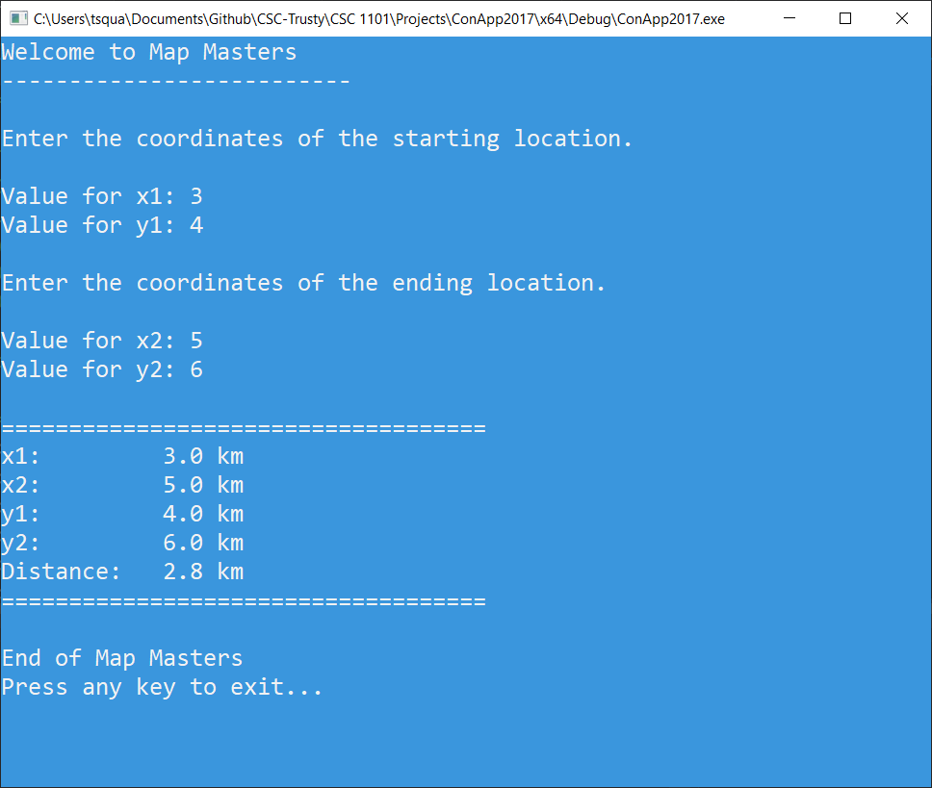

**2) [8 points]** You've been hired by *Minnie Minions* to write a C++ console application that determines the lowest and highest of three real numbers. Prompt the user for the numbers. Use functions:

**fmin(<value-1>, <value-2>)** to get the smallest of <value-1> and <value-2>

And

**fmax(<value-1>, <value-2>)** to get the largest of <value-1> and <value-2>

The result of either function may be stored in a variable and then that variable may be used in the next call of either function. Use formatted output manipulators (setw, left/right) to print the following five rows:

● Value 1

● Value 2

● Value 3

● Lowest value

● Highest value

And two columns:

● A left-justified label.

● A right-justified value.

Define constants for the column widths. Format all real numbers to three decimal places.

**//==========================================================**

**//**

**// Title: Mini Minions**

**// Course: CSC 1101**

**// Lab Number: Lab06-02**

**// Author: Trevor Trusty**

**// Date: 2/1/2019**

**// Description:**

**// User enters three values, and the program shows the user**

**// the lowest and highest value that they entered.**

**//**

**//==========================================================**

**#include <conio.h> // For function getch()**

**#include <cstdlib> // For several general-purpose functions**

**#include <fstream> // For file handling**

**#include <iomanip> // For formatted output**

**#include <iostream> // For cin, cout, and system**

**#include <string> // For string data type**

**using namespace std; // So "std::cout" may be abbreviated to "cout"**

**int main() {**

**//declare variables**

**string title = "Mini Minions";**

**double value1, value2, value3, maxValue, minValue;**

**string units1 = " km";**

**//constants**

**const int col1 = 15;**

**const int col2 = 10;**

**const int prec = 3;**

**cout << "Welcome to " << title << endl;**

**cout << "--------------------------" << endl << endl;**

**//Prompt user for numbers**

**cout << "List 3 numbers, hitting enter after each one" << endl;**

**cout << "Enter Value: ";**

**cin >> value1;**

**cout << "Enter Value: ";**

**cin >> value2;**

**cout << "Enter Value: ";**

**cin >> value3;**

**//Find Max and Min**

**maxValue = fmax(value1, value2);**

**maxValue = fmax(maxValue, value3);**

**minValue = fmin(value1, value2);**

**minValue = fmin(minValue, value3);**

**//Show table**

**cout << "====================================" << endl;**

**cout << fixed << setprecision(prec);**

**cout << setw(col1) << left << "Value 1:";**

**cout << setw(col2) << right << value1 << endl;**

**cout << setw(col1) << left << "Value 2:";**

**cout << setw(col2) << right << value2 << endl;**

**cout << setw(col1) << left << "Value 3:";**

**cout << setw(col2) << right << value3 << endl;**

**cout << setw(col1) << left << "Highest value:";**

**cout << setw(col2) << right << maxValue << endl;**

**cout << setw(col1) << left << "Lowest value:";**

**cout << setw(col2) << right << minValue << endl;**

**cout << "====================================" << endl;**

**cout << "\nEnd of " << title << endl;**

**cout << "Press any key to exit...";**

**_getch();**

**}**

**If possible, format your code like this:**

**Font “Courier New”**

**Font size “9”**

**Bold**

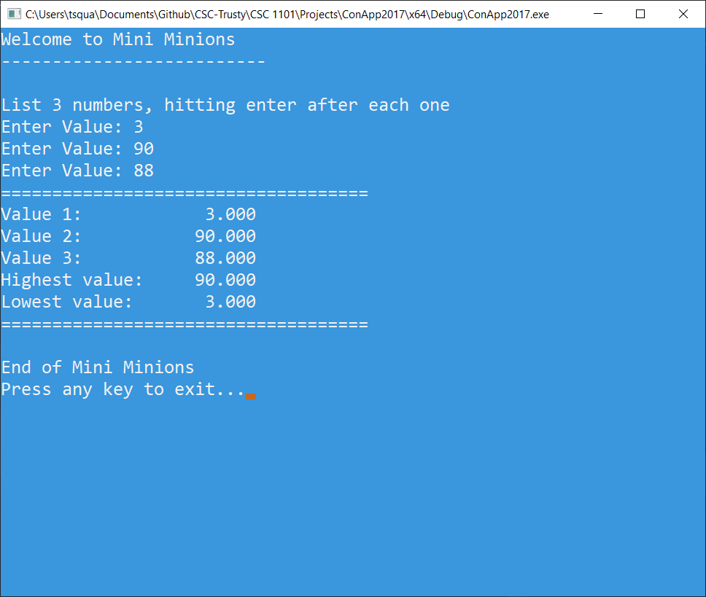

**3) [9 points]** You've been hired by *Heat Hunters* to write a C++ console application that calculates and displays the Celsius equivalent of a Fahrenheit temperature. Prompt the user for a temperature in Fahrenheit, convert it to Celsius and show both values. See <https://www.albireo.ch/temperatureconverter/formula.html> for background information. Use formatted output manipulators (setw, left/right) to print the following two rows:

● Fahrenheit temperature

● Celsius temperature

And three columns:

● A left-justified label.

● A right-justified value.

● A left-justified units (output manipulators not needed here, but **don't** place one space before the units name to separate it from the second column).

Define constants for the column widths. Format all real numbers to two decimal places. Include the degree symbol in the output:

● Windows users – declare a constant for the degree symbol:

DEGREE_SYMBOL = (char) 167

Use the constant in the output.

● Mac OS users – copy the degree symbol above to your code.

Run the program five times with the following Fahrenheit values. What are the results?

|  |  |  |
| --- | --- | --- |
| Run | Fahrenheit | Celsius |
| 1 | 212 | 100.00 |
| 2 | 67 | 19.44 |
| 3 | 32 | 0.00 |
| 4 | 0 | -17.78 |
| 5 | -40 | -40 |

**//==========================================================**

**//**

**// Title: Heat Hunters**

**// Course: CSC 1101**

**// Lab Number: Lab06-03**

**// Author: Trevor Trusty**

**// Date: 2/1/2019**

**// Description:**

**// User enters temperature in fahrenheit and the program**

**// converts it to degrees celcius.**

**//==========================================================**

**#include <conio.h> // For function getch()**

**#include <cstdlib> // For several general-purpose functions**

**#include <fstream> // For file handling**

**#include <iomanip> // For formatted output**

**#include <iostream> // For cin, cout, and system**

**#include <string> // For string data type**

**using namespace std; // So "std::cout" may be abbreviated to "cout"**

**int main() {**

**/\***

**2) write down temperature in degrees Fahrenheit.**

**3) subtract 32 away from original temperature**

**4) multiply resulting number by 5**

**5) divide new number by 9**

**6) write the desired units, ℃, after the quotient**

**\*/**

**//declare variables**

**double userDeg;**

**double celc;**

**//constants**

**const string TITLE = "Heat Hunters";**

**const int COL1 = 15;**

**const int COL2 = 10;**

**const char DEG = 167;**

**cout << "Welcome to " << TITLE << endl;**

**cout << "--------------------------" << endl << endl;**

**//Promt user for temperature**

**cout << "Enter temperature in degrees fahrenheit, " << endl;**

**cout << "and the Cesius equivelent will be calculated for you." << endl;**

**cout << "\nTemperature(" << DEG << "F): ";**

**cin >> userDeg;**

**cout << endl;**

**//Convert to Celcius**

**celc = userDeg;**

**celc -= 32;**

**celc *= 5;**

**celc /= 9.;**

**//Show table**

**cout << "====================================" << endl;**

**cout << fixed << setprecision(2);**

**cout << setw(COL1) << left << "Fahrenheit:";**

**cout << setw(COL2) << right << userDeg << " " << DEG << "F" << endl;**

**cout << setw(COL1) << left << "Celcius:";**

**cout << setw(COL2) << right << celc << " " << DEG << "C" << endl;**

**cout << "====================================" << endl;**

**cout << "\nEnd of " << TITLE << endl;**

**cout << "Press any key to exit...";**

**_getch();**

**}**

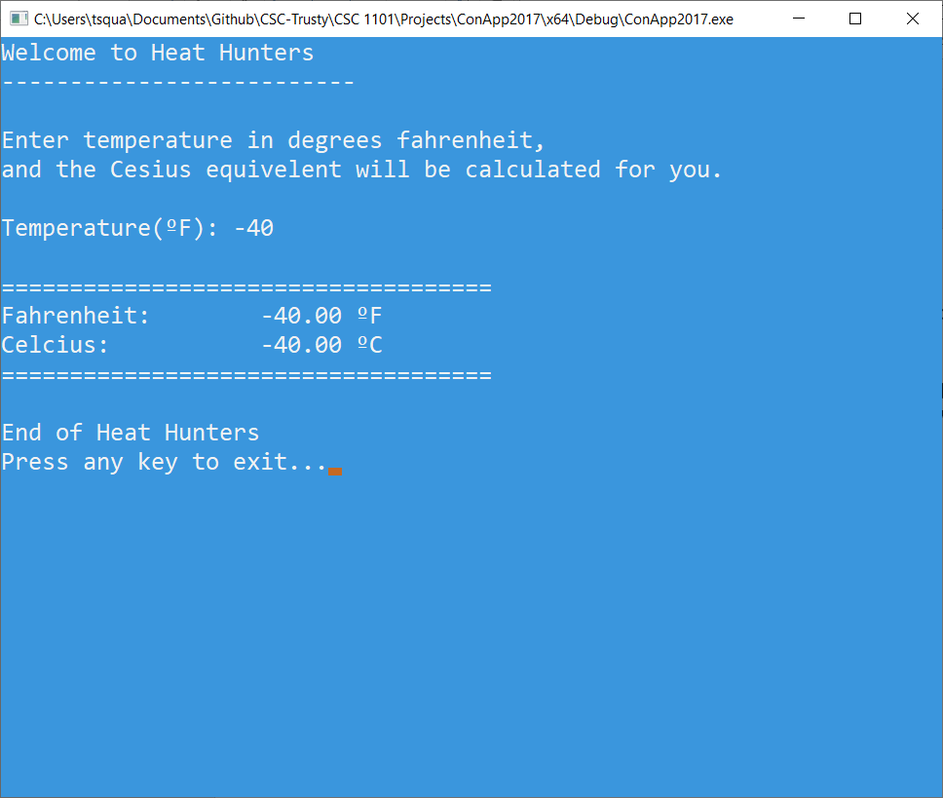

* **Copying-and-pasting Visual C++ code to a Word document**

1) From within the Visual C++ program, press **CTRL-A** and press **CTRL-C**.

2) From within the Word document, press **CTRL-V**.

** **Copying-and-pasting Visual C++ console application output to a Word document**

1) From the Visual C++ console, press **ALT-PrintScreen**.

2) From within the Word document, press **CTRL-V**.